Delsarte

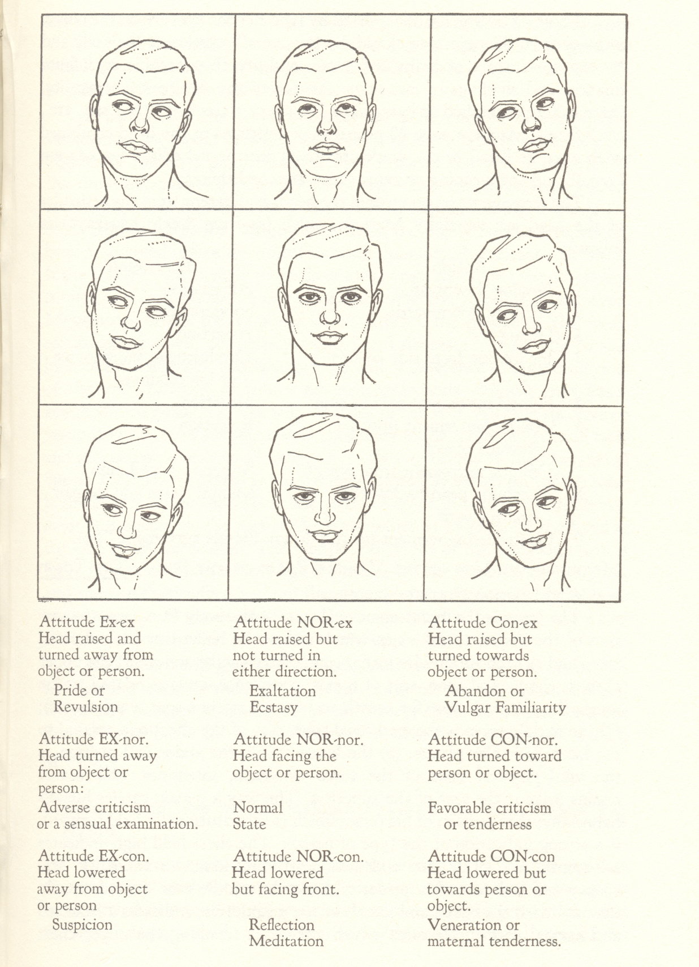

Fig. 1 “Attitude of the Eyeball” in Ted Shawn, *Every Little Movement* (New York:

Dance Horizons, 1954).

Copyright: the Princeton Book Company and the Library of Congress

[\*\*\* COPYRIGHT RELEASE IS REQUIRED BEFORE THIS IMAGE CAN BE USED.]